GOVERNMENT OF MIZORAM

OFFICE OF THE MEDICAL OFFICER

THENZAWL COMMUNITY HEALTH CENTRE

SERCHHIP DISTRICT : MIZORAM

Dated : Thenzawl, 22.09.2023

Ni 22 Sep 2023 Khan Thenzawl CHC ah MHSSP (IPA) bul tumin Free Clinic neih a ni a, Dr.Lalruatliana Surgeon Serchhip Hospital chuan Thenzawl CHC damlo eng e maw zat a lo en a ni.

Hemi ni hian Zing Dar: 9:30Am ah hming ziak tan in Zing Dar: 10:00Am ah Doctor hi a thu tan ani. Dr.Lalruatliana Surgeon hian damlo 20 en in a hmun ah damlo pali a zai chilh nghal a ni.

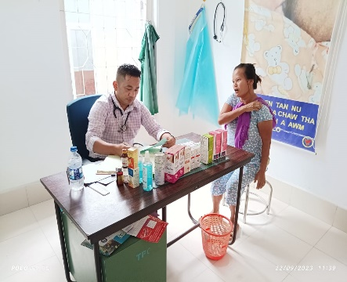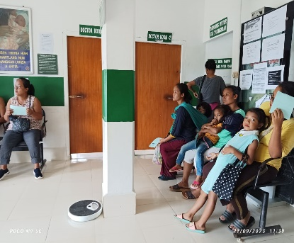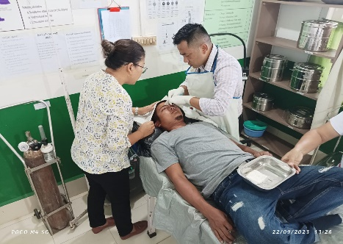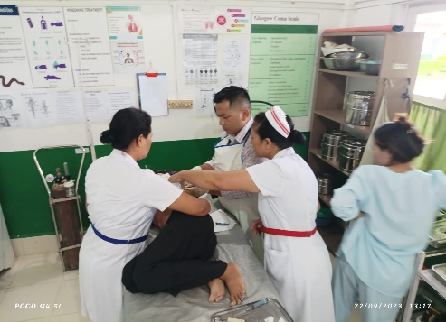

(DR.REMLALNGHAKI)

MEDICAL OFFICER

THENZAWL CHC